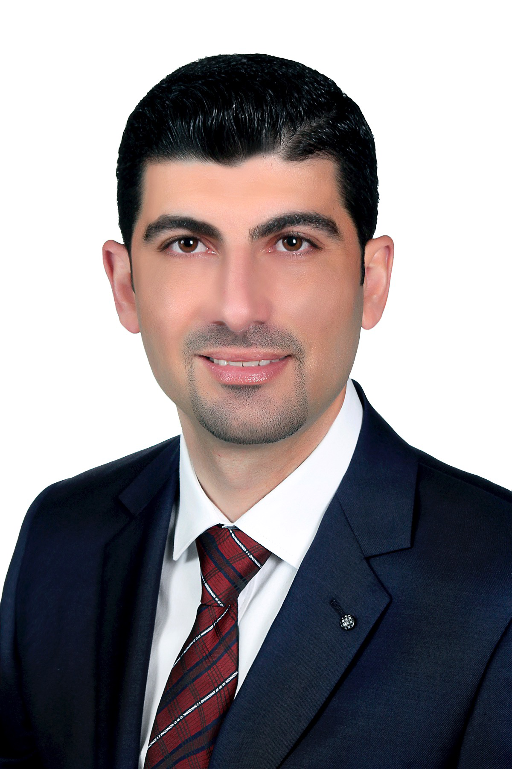 |  | Ghaith Bahjat Heilat  Breast, Endocrine and General Surgeon  MD, JBS, MS, FACS, FEBS
Contact details:  - Faculty of Medicine.  - Jordan University of Science and Technology .  - Irbid-Jordan.  PHONE:  +962777458889  EMAIL: |  | EDUCATION  Professtional memberships  2020 – Present European Society of Surgical Oncology ESSO.  2019 – Present European Board of Surgery FEBS.  2019 – Present BreastSurgANZ Association.  2019 – Present Fellow at American College of Surgeons.  2016 – Present Jordanian Medical Council.  WORK EXPERIENCE  CONFERENCEs, Courses and WORKSHOPS  WEBINARS  29 April, 2023. HER2 positive disease, By the iBreast Book.  25 March, 2023 Save the nipple, By the iBreast Book and GReTA.  25 February, 2023. Chest wall perforator flap revisited, By Breast Surgeons ANZ, BREASTICS and the iBreast Book.  28 January, 2023. High risk and B3 lesions, By the Breast Surgery International BSI and iBreast Book.  07 January, 2023. What’s new in Breast Surgery, By the iBreast Book.  24 September, 2022. Oncoplastic Atlas Part 2, By the iBreast Book, BREASTICS and SENATURK.  25 June, 2022. Implants vs Flaps, By the iBreast Book and GReTA.  11 June, 2022. Oncoplastic Atlas Part 1, By By the iBreast Book, SENATURK and GReTA .  02 April, 2022. Controversies, By the iBreast Book and Ocnoplastic Academy.  29 January, 2022. Lymphoedema, By the iBreast Book.  08 January, 2022. The best of 2021, By the iBreast Book.  20 November, 2021. Chest wall perforator flaps, By the iBreastBook.  30 October , 2021. The little things that matter, By the iBreastBook.  09 October, 2021. Fluorescence in breast surgery, By the iBreastBook.  28 August, 2021. The mammoplasty, By the iBreastBook.  31 July, 2021. Lipomodelling: The Art of Fat, By the iBreastBook and G.RE.T.A.  10 July, 2021. Dragon's Den: What's new in breast surgery, By the iBreastBook.  25-27 June, 2021. The 1st BreastGlobal Conference.  12 June, 2021. Conference updates (St Gallen's Consensus, ABS Conference update and ASBrS Conference ​update).  29 May, 2021. A Functional MDT, By. Breast Global.  22 May, 2021. Chemotherapy as a Surgical Tool, By the iBreastBook.  08 May, 2021. Intermediate Oncoplastic Techniques Teleconference (Level2), By Stryker.  07 May, 2021. The future is paramagnetic, By the iBreastBook.  10 April, 2021 Breast Reconstruction, Free Flaps and Microsurgery, By iBreastBook.  08 April, 2021 Therapeutic reduction mammoplasty tips & tricks, By AMTC Webschool.  27 March, 2021 B3 Lesions: Diagnosis and Management, By the iBreastBook.  06 March, 2021 Introductory Oncoplastic Techniques Teleconference (Level1), By Stryker.  05 March, 2021 Basics of Cosmetic Breast Surgery, By the iBreastBook and G.RE.T.A.  20 February, 2021 ESSO Webinar on Oncoplastic Breast Surgery: Volume Replacement.  06 February, 2021 Breast Surgery is Less More, By the iBreastBook and SENATURK  23 January, 2021 MANAGING THE AXILLA: LESS IS MORE, By the iBreastBook.  21-22 January, 2021 The 13th Breast-Gynaecological & Immunooncology International Cancer Conference.  09 January, 2021 ONCOPLASTIC BREAST SURGERY: PART 1, By iBreastBook.  12 December, 2020 QUALIFICATIONS AND FELLOWSHIPS IN BREAST SURGERY, By iBreastBook.  skills  Publications  - Alrosan, Amjad Z.; Heilat, Ghaith B.; Al Subeh, Zeinab Y.; Alrosan, Khaled; Alrousan, Alaa F.; Abu-Safieh, Amro K.;, Alabdallat, Nuwar S. : The effects of statin therapy on brain tumors, particularly glioma: a review : Anti-Cancer Drugs. Jul 2023. DOI: 10.1097/CAD.0000000000001533  - Amjad Z. Alrosan, Khaled Alrosan, Ghaith B. Heilat, Rawan Alsharedeh, Rawan Abudalo, Muna Oqal, Abdelrahim Alqudah, Yasmin A. Elmaghrabi: Potential roles of NEDD4 and NEDD4L and their utility as therapeutic targets in high-incidence adult male cancers (Review): Molecular and clinical Oncology.Jul 2023. DOI: 10.3892/mco.2023.2664  - Naser Obeidat, Ghaith Heilat, Tarek Ajam, Hamzeh Al-Zoubi. Perforated Stress Ulcer ofthe Duodenum: a Case of anUnexpected Diagnosis in aCOVID-19 Patient FollowingDilatation and Curettage Procedure: Medical Archives. 2023 Apr. DOI: 10.5455lmedarh.2023.77.155-157  - Rawan H. Alsharedeh, Nida Alshraiedeh, Rawan Huwaitat, Mamduh Alqatan, Esra' O. Taybeh, Amjad Z. Alrosan, Ghaith B. Heilat. Public perceptions of the COVID-19 Pandemic: A National Cross-sectional Study. Research Journal of Pharmacy and Technology. 2022 Sep, DOI:10.52711/0974-360X.2022.00692  - Brennan ME, Morgan M, Heilat GB, Kanesalingam K. Granulomatous lobular mastitis: Clinical update and case study. Aust J Gen Pract. 2020 Jan-Feb;49(1-2):44-47. doi: 10.31128/AJGP-08-19-5042. PMID: 32008263.  - Kanesalingam K, Sriram N, Heilat G, Ng EE, Meybodi F, Elder E, Brennan M, French J. Targeted axillary dissection after neoadjuvant systemic therapy in patients with node-positive breast cancer. ANZ J Surg. 2020 Mar;90(3):332-338. doi: 10.1111/ans.15604. Epub 2019 Dec 17. PMID: 31845501.  - Kanesalingam K, Heilat G, Sood S, Samarasinghe P, Elder E, French J, Brennan M, Meybodi F. Postmastectomy radiotherapy and immediate implant-based breast reconstruction: attitudes and practices of Australian and New Zealand breast surgeons. ANZ J Surg. 2019 Oct;89(10):1186-1187. doi: 10.1111/ans.15288. PMID: 31621162.  - Heilat GB, Brennan ME, Kanesalingam K, Sriram N, Meybodi F, French J. Presentation, tumour and treatment features in immigrant women from Arabic-speaking countries treated for breast cancer in Australia. ANZ J Surg. 2020 Mar;90(3):325-331. doi: 10.1111/ans.15596. Epub 2019 Dec 16. PMID: 31845467.  - Poster presentation in the Breast Surgery Section of the Royal Australasian College of Surgeons (RACS) Annual Scientific Congress in Bangkok, 6-10 May 2019.  - Poster presentation at Australian society for breast disease ASBD 12th scientific meeting in Gold Coast, 11-12 October 2019.  - This had media interest. SBS TV World News had a report and interview about it. See the link: https://www.sbs.com.au/news/exclusive-arab-women-in-australia-linked-to-more-aggressive-breast-cancers  - Heilat GB, Brennan ME, French J. Update on the management of early-stage breast cancer. Aust J Gen Pract. 2019 Sep;48(9):604-608. doi: 10.31128/AJGP-03-19-4891. PMID: 31476829.  - Hijazi, E. , Khamash, M. , Balas, H. and Heilat, G. (2014) Intramural cardiac hydatid cyst—Incidental finding. World Journal of Cardiovascular Diseases, 4, 5-8. doi: 10.4236/wjcd.2014.41002.
  g.heilat@yahoo.com
  gbheilat@just.edu.jo
  Jul. 2022 The Jordanian Board of Breast Surgery
  Jordanian Medical Council
  Amman, Jordan
  Sep. 2019 – Aug. 2020 Head & Neck/Surgical Oncologist Fellowship
  The Crown Princess Mary Cancer Center,
  Westmead Hospital/ Royal Australian
  College of Surgery,
  The University of Sydney
  Sydney, Australia
  28 Sep. 2019 |  |  |  | The European Board of Breast Surgery  European Board of Surgery Qualification  in Breast Surgery FEBS  Bucharest, Romania
  Sep. 2017 – Sep. 2019 |  |  |  | Breast Oncoplastic Surgical Fellowship
   |  |  |  | Breast cancer institute BCI,  Westmead Hospital/ Royal Australian  College of Surgery,  The University of Sydney  Sydney, Australia |  |  | Irbid, Jordan
  Apr. 2016 The Jordanian Board of /General Surgery
  Jordanian Medical Council
  Amman, Jordan
  Jul. 2010 – Jun. 2015 Higher specialty certificate (MS) in General Surgery
  Jordan University of Science and Technology
  Faculty of Medicine
  Irbid, Jordan
  Jul. 2010 – Jun. 2015 General Surgery Residency
  Core Surgical Training
  King Abdullah University Hospital
  Irbid, Jordan
  Jul. 2009 – Jun. 2010 Internship
  King Abdullah University Hospital
  Irbid, Jordan
  Mar. 2009 – May. 2009 Elective course training
  Houston Medical Center
  Georgia, USA
  Sep. 2003 – Jun. 2009 Bachelor’s degree in Medicine and Surgery
  Jordan University of Science and Technology
  Faculty of Medicine
  Irbid, Jordan
  Sep. 2002 – Aug. 2003 General Secondary Education Certificate
  Examination
  Jordan Ministry of Education
  Irbid, Jordan
  Oct. 2022 – present |  |  | Breast oncoplastic and General Surgeon  King Abdullah University Hospital  Irbid, Jordan
  Oct. 2022 – present |  |  | Assistant Professor of Medicine & Surgery
  Mar. 2021- Jul. 2022 |  |  | Faculty of Medicine  Jordan University of Science and Technology  Irbid, Jordan  Breast oncoplastic and General Surgeon
  Princess Basma Teaching Hospital
  Ministry of Health
  Irbid, Jordan
  Sep. 2020 – Jul. 2022 |  |  | Assistant Professor of Medicine & Surgery
   |  |  | Faculty of Medicine  Yarmouk University  Irbid, Jordan | Zarqa, Jordan
  Sep. 2019 – Aug. 2020 Surgical Fellow/H&N Surgery
  The Crown Princess Mary Cancer Center
  Westmead Hospital/RACS
  The University of Sydney
  Sydney, Australia
  Sep. 2017 – Sep. 2019 Surgical Fellow/Breast Surgery
  Breast cancer institute BCI
  Westmead Hospital/RACS
  The University of Sydney
  Sydney, Australia
  Apr. 2017 – Aug. 2017 |  |  | General Surgeon
  Doctors Without Borders/ MSF
  Alramtha Hospital
  Irbid, Jordan
  Oct. 2016 – Aug. 2017 Instructor
  Faculty of Medicine
  Yarmouk University
  Irbid, Jordan
  Aug. 2015 – Sep. 201 |  |  | General Surgery Specialist
  Al-Essra Hospital
  Amman, Jordan
  28-29 Sep. 2020 LEVEL 3 Istanbul Reconstructive Breast Cancer
  Surgery Workshop (Distinction)
  SENATURK IREBS 2020
  Istanbul, Turkey
  May. 2020 ACLS Certification Course
  The Postgraduate Institute for
  Medicine PIM/ NHCPS Online
  .
  May. 2020 BLS Certification Course
  The Postgraduate Institute for
  Medicine PIM/ NHCPS Online
  10-12 Oct. 2019 ASBD 12th Scientific Meeting
  Australian Society for Breast Disease
  RACV Royal Pines Resort
  Gold Coast, Queensland, Australia
  Zarqa, Jordan.
  9-10 Oct. 2019 LEVEL 2 Oncoplastics Breast Surgery Workshop
  Sister Edith Education Centre Chermside
  BreastSurgANZ
  Brisbane, Australia
  Aug. 2019 LEVEL 1 Oncoplastics Breast Surgery Workshop
  Crowne Plaza Hotel
  BreastSurgANZ
  Queenstown, New Zealand
  6-10 May. 2019 Royal Australian college of Surgeons
  88th Annual Scientific Congress
  Centara grand & Bangkok Convention Centre
  Bangkok, Thailand
  Mar. 2019 Applied Ultrasound for Breast surgeon and clinician
  Australian Society for breast disease
  Melbourne, Australia
  Mar. 2019 Communication skills workshop
  Australian Society for breast disease
  Melbourne, Australia
  Aug. 2018 Fat transfer and breast lipomodelling technique
  ADIP sculpt
  Sydney, Australia
  Surgical skills |  | Competent and specialized in:
  -Breast oncoplastic procedures.
  - Head & Neck Endocrine procedures.
  - General surgery procedures.
  MDT skills |  | Participated and run more than 290 meetings.
  Research Related Skills |  | Professional skills.
  Computer Skills |  | Professional skills in using:
   |  | - Windows.  - Microsoft Office applications. | Zarqa, Jordan.
  Languages
  - Arabic (Native language).
  - English (Fluently spoken and written).
Referees and Logbook are available upon request

Updated on 10.08.2023

Dr. Ghaith Bahjat Heilat

