CURRICULUM VITAE

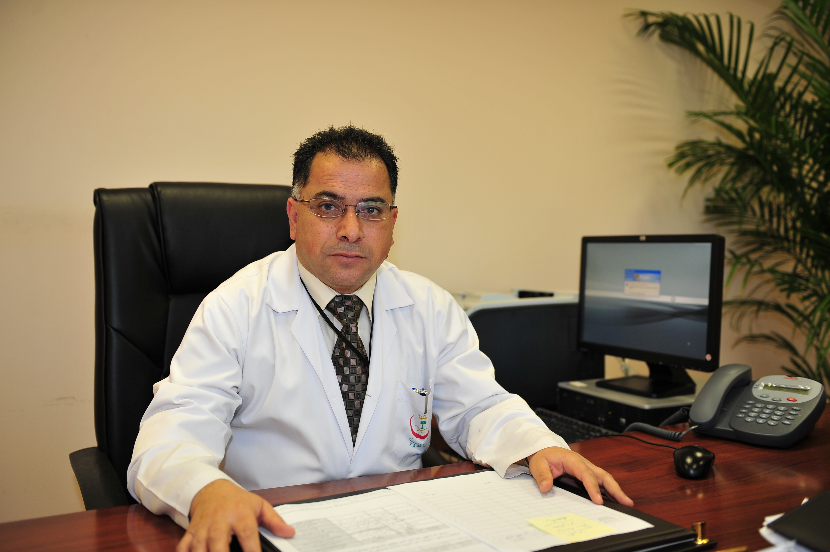

Dr. Hani Abdalla El Taani

Mobile: 00962-778173153
E.Mail: hanieltaani@hotmail.com

Degrees, Specialization and Sub-specialty:

- 1990 – Doctor of Medicine and Surgery, University of Perugia, Italy. 1990
- November 1994 – Specialist in Oncology (Medical Oncology), University of Perugia, Italy.
- November 1995 – Jordanian Medical Council Board in Oncology.
- October 2005 - European certification in Medical Oncology, Examination held in Paris, France.
- June 1998 - June 2000 – Bone Marrow Transplantation, Fellowship in Hematoncology Division, Bone Marrow Transplantation Unit, European Institute of Oncology, Milan Italy. “
- 2001- Jordanian Medical Council certificate in Bone Marrow Transplantation.
- June 2010 – Saudi Commission for Health Specialties, as Consultant Medical Oncologist, ID 10-R-M-0338866.

Professional Experience
- March 1996 – January 2004 – Specialist in Oncology, Department of Oncology, Ministry of Health (MOH), Al-Bashir Hospital, Amman, Jordan. Chairman of medical Oncology unit.
- Oct. 2001- May 2002- consultant Medical Oncologist and Bone Marrow Transplantation at King Hussein Cancer Center (Part Time).
- January 2004 – January 2010 – Consultant Medical Oncologist and Bone marrow Transplant at King Hussein Cancer Center, Chairman of Gastro-intestinal Service, Cancer Unknown Primary service and Thoracic Cancer Service.
- January 2010- January 2020: Consultant Medical Oncology, Chairman of Medical Oncology Service, deputy chairman of Oncology Center at King Abdullah Medical City in Holly Capital, Makkah, KSA.
- January 2011 till June 2011: Director of Oncology Center at King Abdullah Medical City in Holly Capital, Makkah , KSA

Current Position
- January 2019 till present: Senior Consultant in Medical Oncology at King Abdullah University Hospital – Clinical instructor at Jordan University for science and Technology

Invited Speaker
- Invited speaker in many national and international meeting and conferences

Publications and Abstracts

Author and Co author of 85 abstracts and publications

Scientific Memberships | • Italian Medical Association, Perugia, Italy, since August 1991.  • Italian Medical Oncology Association (AIOM), since 1995.  • Jordan Medical Association, since 1991.  • Jordanian Oncology Association, since April 1996.  • American Society of Clinical Oncology (ASCO), October 1999.  • European Society for Medical Oncology (ESMO), March 2000.  • International Association for the Study of Lung Cancer (IASLC) September 2007.

