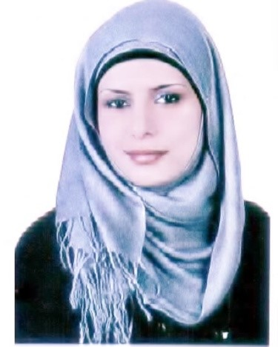 |  |  |  | Dr. Kamleh Barham, MD  Pediatric Specialist  Pediatric Gastroenterologist

Current Position:
April 2022–now

- Pediatric Gastroenterologist / King Abdullah University Hospital
- Assistant Professor of Pediatric /Medical school /Jordan University of Science and technology

Experience :
February 2020 –February 2022

- Gastroenterology, Hepatology and clinical nutrition Fellow / Royal Children’s Hospital of Melbourne /Australia
August 2016 – October 2019

- Full time Clinical lecturer / Jordan University of Science and technology
- Pediatric Specialist / Jordan University of Science and technology Health Care Centre

Clinical Training

February 2020- February 2022

- Gastroenterology, Hepatology and Clinical Nutrition Fellowship / Royal Children’s Hospital of Melbourne /Australia
July 2011 -July 2015

- Pediatric Residency / King Abdullah University Hospital/Jordan

July 2010 –July 2011

- Internship / King Abdullah University Hospital/Jordan

Academic and Clinical Qualification:

- Jordanian Medical Council Recognition as Gastroenterology specialist
(www.jmc.gov.jo) 2022

- Clinical Gastroenterology, Hepatology and Clinical Nutrition Fellowship Royal Children’s Hospital of Melbourne /Australia 2022

- MRCPCH PART 1A,1B, AND PART 2 Royal College of Pediatrics and Child Health (www.rcpch.ac.uk) 2017

- Jordanian Board in Pediatrics Jordanian Medical Council (www.jmc.gov.jo) 2015

- Certificate of Higher Specialization in Pediatrics Jordan university of science and technology (www.just.edu.jo) 2015
King Abdullah University Hospital (KAUH) , Jordan (www.kauh.jo)

- Medicine Bachelor and Bachelor of Surgery (MBBS) Faculty of Medicine, Jordan University of Science and Technology (www.just.edu.jo) 2010

- Secondary Education Certificate Ministry of Education of Jordan (www.moe.gov.jo) 2010

Procedural skills:

- Upper Endoscopy & biopsy
- Lower Endoscopy & biopsy
- PEG tube insertion and removal
- Upper and Lower Gi Therapeutic endoscopy (Ulcers, Varices, polyps ect)

Licenses:

- Unrestricted license to perform Upper and Lower endoscopy in Jordan /Jordanian Society of Gastroenterology and Hepatology (22866)

- Unrestricted license to practice Medicine in Jordan, Work Permit number: (2001/17666)
- Unrestricted license to practice General pediatric medicine in Jordan, Work Permit number: (10020/1094)
- BLS (American heart association at KAUHTC, JORDAN) /2023

- PALS (American heart association KAUHTC, JORDAN)/2023

- Conscious Sedation (KAUH, JORDAN)/2023

- GCP certified by the GLOBAL HEALTH NETWORK in 30/9/2017

- Work with children (Victoria state Government /Australia)/2020

Scholarships:
- Awarded a scholarship to continue Pediatric gastroenterology training / Jordan University of Science and Technology 2019
- Awarded a scholarship to study Medicine / National Prize (Ministry of Higher Education, Jordan. 2004)

Publications:
- A Fat Overload after Fat Emulsion High Dose Infusion in an Infant: A case report published at the Pediatrics & Therapeutics Journal, in June 30, 2015.

Memberships:
- JOSPGHAN (Jordanian Society of Pediatric Gastroenterology, Hepatology and Clinical Nutrition) 2022
- JSGH (Jordanian Society of Gastroenterology and Hepatology )2023
- JPS (Jordan Pediatric Society) 2023
- AHPRA 2020- 2022
- RACP 2020 -2022
- Jordanian Medical Association 2010- now
- Jordanian Medical Council 2015
- JUST Alumni 2010

Conferences:
- Speaker at The 23rd International Congress of the Jordanian Society of Gastroenterology and Hepatology /2023
- Speaker at The 11th International Medical Congress of the Jordanian Medical Association /2023
- Speaker at Celiac disease awareness campaign (Jordan Celiac Society)/2022

 |  | Mobile:
Email:
kabarham@just.edu.jo
Mailing Address:
Dr. Kamleh Barham
Faculty of Medicine
Jordan university of Science and technology
P.O. Box 3030, Irbid 22110

