Curriculum Vitae

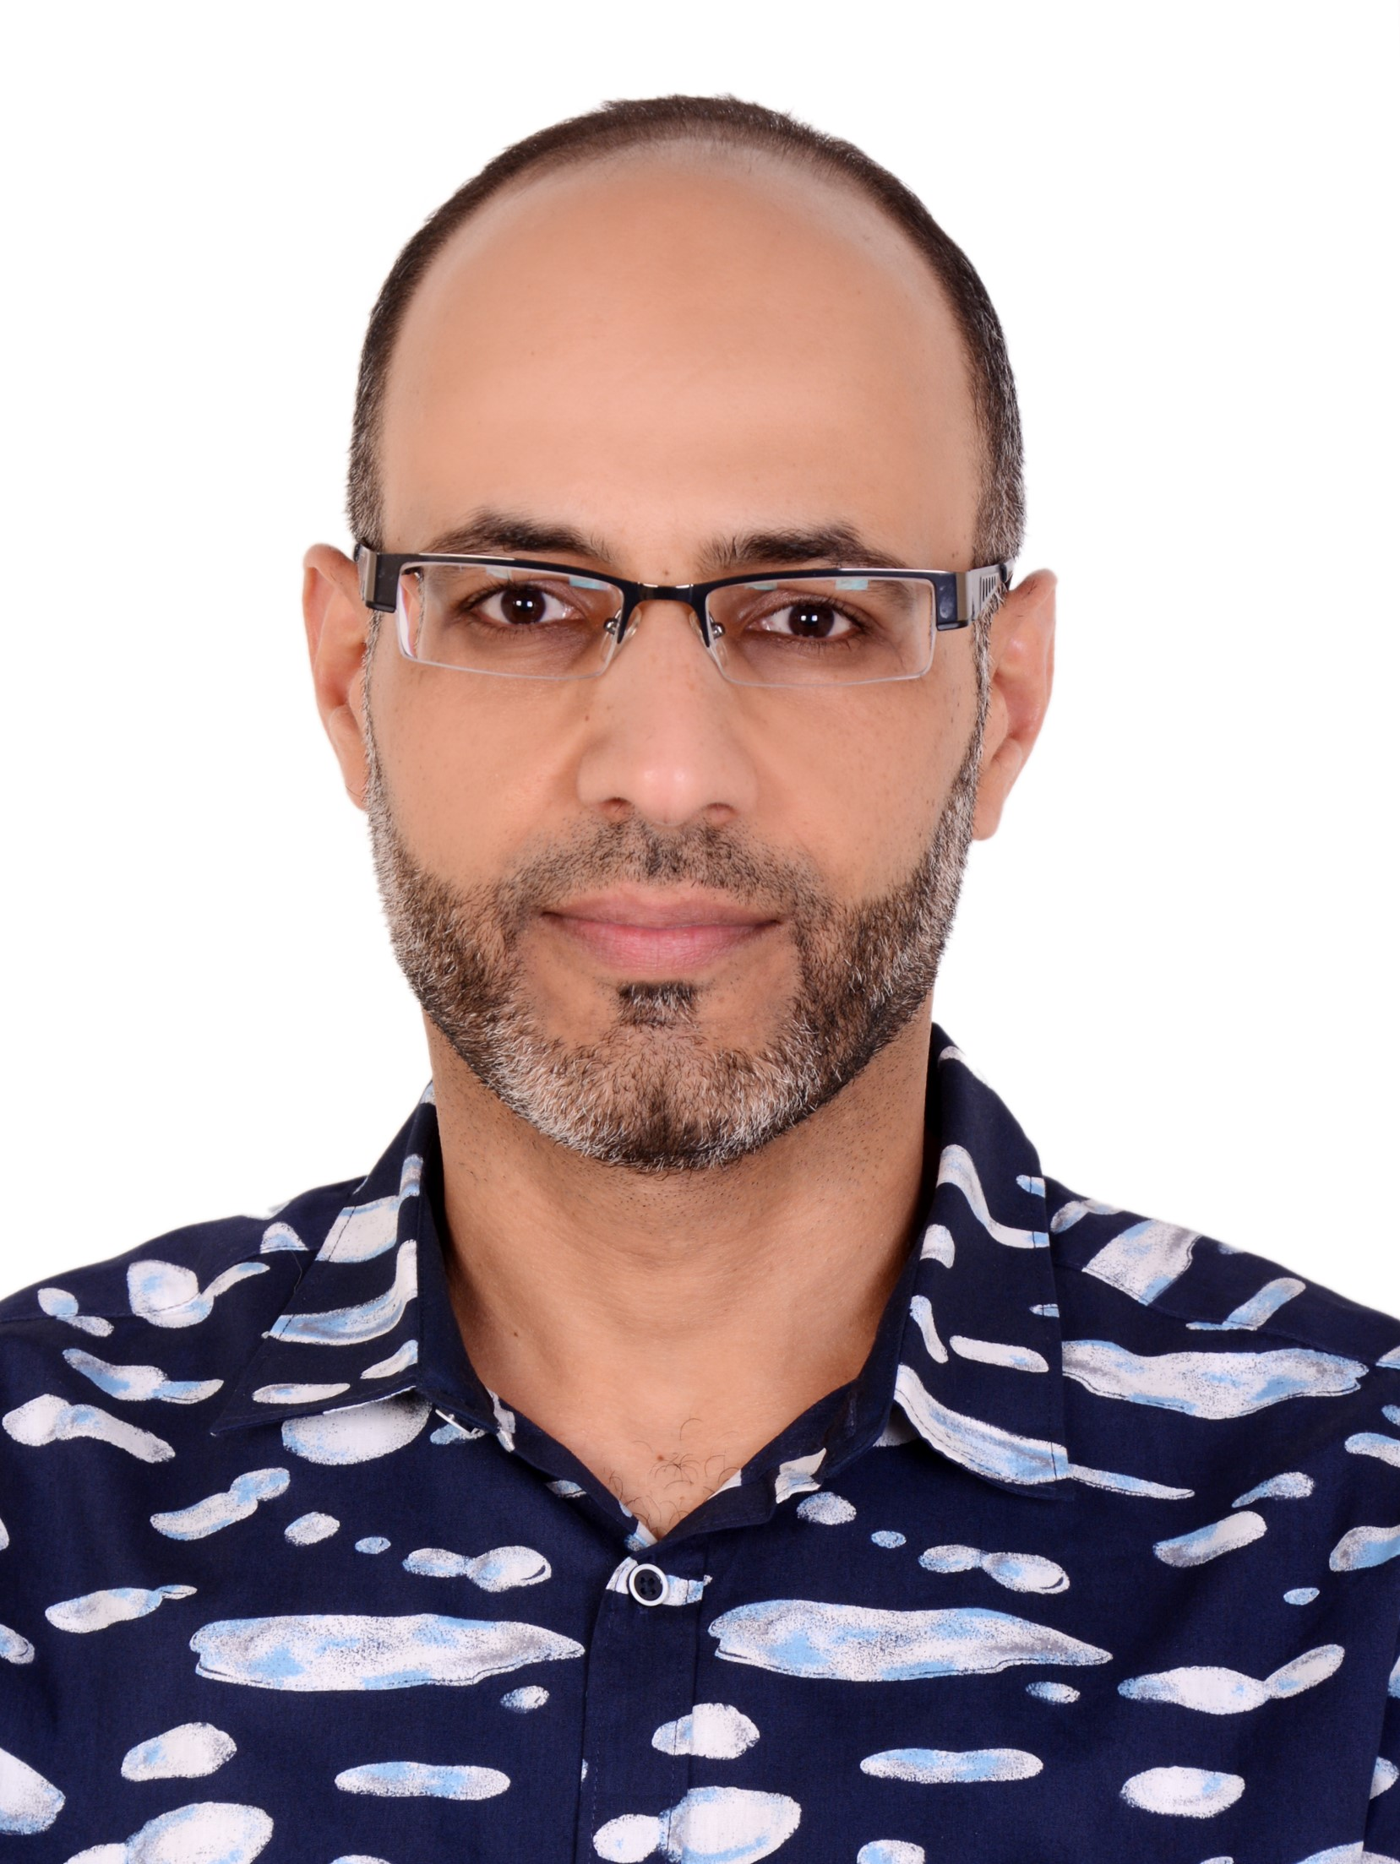

MOHAMMAD TANASH
M.D, UROLOGIST

Personal DetailS:

Family Name (Surname) | Tanash
Given Names | Mohammad Ahmed Abedalla
Date of Birth | 05/01/1983
Gender | Male
Current Work Address | Paediatric Urology consultant at King Abdullah University Hospital / Assistant Professor at Jordan University of Science and Technology
Current Home Address | Irbid, Jordan 21146
Phone | Mobile +962799051437
Contact email address | mohammad.tanash@yahoo.com

Qualifications:

Primary Medical Qualification (MBBS or equivalent):
Qualification title: | MBBS
Year Qualified: | 2007
Year Awarded (If different to year qualified for degree): | 2007
Country of Training: | Jordan
Medical School: | Faculty of medicine
Controlling University: | Jordan University of Science and Technology
Was a period of internship included in qualification? NO

Specialist Qualification:
Qualification title: | Jordanian Board of Urology
Year Qualified: | 2013
Year Awarded (If different to year qualified for degree): | 2013
Country of Training: | Jordan
Institution Awarding qualification: | Jordan Medical Council
Duration of training | 5 years

Qualification title: | Paediatric Urology Fellowship
Year Qualified: | 2023
Year Awarded (If different to year qualified for degree): | 2023
Country of Training: | Australia
Institution Awarding qualification: | Sydney Children’s Hospitals Network
Duration of training | 3 years

Additional Qualifications:
Qualification title: | Master of Higher Specialty in Medicine - Urology
Year Qualified: | 2013
Year Awarded: | 2013
Country of Training: | Jordan
Institution Awarding qualification: | Jordan University of Science and Technology

Current & All Previous Medical Licensing Authorities:
Type of registration (indicate if licensed to practice as a specialist or not) | Date (from/to) | Registering authority | Any restrictions/conditions or undertakings?
Permanent registration as Urology Consultant | 2013 - present | Jordanian Ministry of Health | No
Medical Practitioner/ Paediatric urology fellow | April 2020 – April 2023 | AHPRA | No
Senior Registrar Urologist | 2016 - 2019 | Saudi Commission for Health Specializations | No

Memberships of Professional Organisations:
Date From/To | Organisation
2014 - now | Member of Royal College of Surgeons of Ireland
2013 - now | Jordanian Medical Association

TRAINING:

Certificates & Courses:

Date | Ce certificates & Courses:
1/2022 | Fire Safety and Evacuation
1/2022 | Preventing and managing bullying, harassment, and discrimination
1/2022 | Hand Hygiene
12/2021 | Promoting acceptable behaviour in the workplace
12/2021 | Privacy – It’s yours to keep
11/2021 | Cyber security fundamentals
1/2021 | L Child wellbeing and child protection
1/2021 | Safety and Quality for medical officers
1/2021 | Open disclosure
11/2020 | Infection prevention strategies for medical officers
9/2020 | Basic life support course
9/2020 | Fire Safety and Evacuation
5/2020 | PPE for combined transmission-based precautions
5/2020 | Medical officer Mandatory training
3/2019 | EinE- Excellence in Endourolgy course, Dubai
1/2018 | ER Triage course, Mecca, Saudi Arabia
6/2017 | Conscious Sedation, Mecca, Saudi Arabia

Detailed Employment History:

EMPLOYMENT IN SPECIALIST PRACTICE
Start/end dates | 07/2023 – present
Institution/Hospital | Jordan University of Science and Technology – King Abdullah University Hospital.
Position title | Paediatric Urology Consultant
Location | P O Box 3030, Irbid 22110 - Jordan
Registering Authority | Ministry of Health
Duties | Paediatric Urology consultant at urology division, covering two outpatient sessions per week  Two days of teaching sessions for medical student  Two days in the operation theatre

Start/end dates | 04/2020 – 02/2023
Institution/Hospital | The Children’s Hospital at Westmead
Position title | Paediatric Urology Fellow
Location | Cnr Hawkesbury Rd &, Hainsworth St, Westmead NSW 2145
Registering Authority | AHPRA
Duties | Paediatric Urology fellow, participating and assisting in the outpatient clinic, Operating theatre, and daily inpatient follow-up.

Start/end dates | 05/2018 – 01/2020
Institution/Hospital | Jordan University of Science and Technology – King Abdullah University Hospital.
Position title | Urology Specialist
Location | P O Box 3030, Irbid 22110 - Jordan
Registering Authority | Ministry of Health
Duties | Urology specialist at the urology division, one-day day outpatient clinic  Two days in teaching sessions for medical student  Two days in the operation theatre

Start/end dates | 07/2015 – 04/2018
Institution/Hospital | Security forces hospital
Position title | Senior registrar urologist
Location | PO Box 14799 – Makkah 21955 – Saudi Arabia
Registering Authority | Saudi Commission for Health Specializations
Duties | Full-time Senior registrar urologist  Two days outpatient clinics  One day in the operating theatre  10 on- call/month covering the ER urological cases and management of urology in-patients.

Start/end dates | 10/2013 – 06/2015
Institution/Hospital | Private Clinic
Position title | Urology Specialist
Location | Irbid - Jordan
Registering Authority | Ministry of Health
Duties | Working in a Private clinic 6 days/week  Morning and afternoon clinic  5 on–call / month covering the ER urological cases at a private hospital  Doing urological procedures and surgeries at a private hospital (Rosary’s sister hospital)
EMPLOYMENT DURING SPECIALIST TRAINING
Start/end dates | 07/2008 – 06/2013
Institution/Hospital | Jordan University of Science and Technology – King Abdullah University Hospital.
Position title | Urology resident
Location | P O Box 3030, Irbid 22110 - Jordan
Registering Authority | Jordan Medical Council
Duties | First-year was at General surgery department (07/2008 – 06/2009)  2nd - 5th year at urology department (07/2009 – 06/2013)  Inpatient management including pre-and post-operative assessment, In-hospital on-call for urological cases at ER, covering outpatient clinics twice/ week, one day every week in the operating theatre doing and assisting urological surgeries, teaching sessions/rounds for medical students, attending regular teaching seminars by consultants.

EMPLOYMENT BEFORE SPECIALIST TRAINING

Start/end dates | 07/2007 – 06/ 2008
Institution/Hospital | Ministry of Health hospitals
Position title | Intern
Location | Irbid - Jordan
Registering Authority | Ministry of Health
Duties | Paediatric department 7/2007 – 9/2007  Emergency department 9/2007 - 10/2007  Internal Medicine department 10/2007 – 01/2008  Obstetrics and Gynaecology department 01/2008 – 03/2008  Primary Health care department 03/2008 – 04/2008  General Surgery department 04/2008 – 06/2008  Assisting in Admission, management, follow up and discharge of in-ward patients.  Participating in the evaluation and management of ER patients  Attending and assisting in OPD clinics  Attending at OR theatre

Research and publications:

- Laparoscopic versus open pyeloplasty in paediatric pelvi‐ureteric junction obstruction, Journal of Paediatrics and Child Health, 2023-05-29, Journal article, DOI: 10.1111/jpc.16443

Continuing Professional Development activities:

11/2022: Attend an update on the Paediatric Urology Meeting over two days, (Asia Pacific Association of Paediatric Urologists).

10/2022: Attending the 19th Urological Association of Asia Congress (UAA 2022).

11/2021: Attend an update on the Paediatric Urology Meeting over two days, (Asia Pacific Association of Paediatric Urologists).

05/2021: Attend SPUNZA Paediatric urology annual course over two days.

04/2020-present; attend regular teaching sessions at The Children’s Hospital at Westmead, Sydney, Australia.

04/2020- present; attend regular Radio-urology meetings, once weekly at The Children’s Hospital at Westmead, Sydney, Australia.

2019; attend Excellence in Endourology workshop done over 3 days in Dubai, UAE.

2017; attend ER triage course done over 2 days in Mecca, Saudi Arabia

2017; attend Conscious sedation course done in Mecca, Saudi Arabia

2017; attend a conference about ' Recent Update in the Management of Genitourinary Cancer ' done over 2 days in Jeddah, Saudi Arabia.

2017; attend a course about 'Last Update in BPH management

Referees:

 | Referee 1 | Referee 2 | Referee 3
Name: | Dr.Grahame Smith | Dr.Aniruddh Deshpande | Dr.Omar Halalsheh
Position: | Head Division of Paediatric Urology | Associate professor- Co-Head of the general surgery department | Assistant professor- Faculty of Medicine
Address: | The Children’s Hospital at Westmead | The Children’s Hospital at Westmead | Jordan University of Science and Technology – King Abdullah University Hospital.
Phone Number: | +61418229221 | +61401098314 | +962790916582
Email Address: | Grahame.smith@health.  nsw.gov.au | Aniruddh.deshpande@health.  nsw.gov.au | omhalalsheh@just.edu.jo
year of most recent contact | 04/2020 – 02/2023 | 04/2020 – 02/2023 | 2018 - 2020

